Lab 1



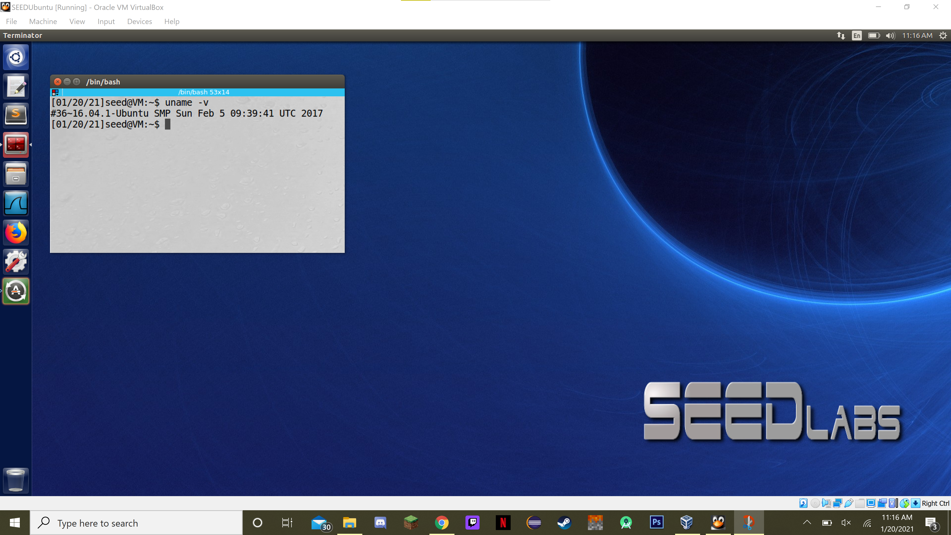

1. **Code:**

#include <stdio.h>

int main(int argc, char **argv, char **envp)

{

for (char **env = envp; *env != 0; env++)

{

char *thisEnv = *env;

printf("%s\n", thisEnv);

}

return 0;

}

**Output:**

[01/20/21]seed@VM:~$ gcc -o lab1 lab1.c

[01/20/21]seed@VM:~$ ./lab1

XDG_VTNR=7

ORBIT_SOCKETDIR=/tmp/orbit-seed

XDG_SESSION_ID=c1

XDG_GREETER_DATA_DIR=/var/lib/lightdm-data/seed

IBUS_DISABLE_SNOOPER=1

TERMINATOR_UUID=urn:uuid:6916a6eb-0685-4383-aed3-408e1bc6eba8

CLUTTER_IM_MODULE=xim

SESSION=ubuntu

GIO_LAUNCHED_DESKTOP_FILE_PID=3154

ANDROID_HOME=/home/seed/android/android-sdk-linux

GPG_AGENT_INFO=/home/seed/.gnupg/S.gpg-agent:0:1

TERM=xterm

SHELL=/bin/bash

DERBY_HOME=/usr/lib/jvm/java-8-oracle/db

QT_LINUX_ACCESSIBILITY_ALWAYS_ON=1

LD_PRELOAD=/home/seed/lib/boost/libboost_program_options.so.1.64.0:/home/seed/lib/boost/libboost_filesystem.so.1.64.0:/home/seed/lib/boost/libboost_system.so.1.64.0

WINDOWID=58720260

UPSTART_SESSION=unix:abstract=/com/ubuntu/upstart-session/1000/1143

GNOME_KEYRING_CONTROL=

GTK_MODULES=gail:atk-bridge:unity-gtk-module

USER=seed

LS_COLORS=rs=0:di=01;34:ln=01;36:mh=00:pi=40;33:so=01;35:do=01;35:bd=40;33;01:cd=40;33;01:or=40;31;01:mi=00:su=37;41:sg=30;43:ca=30;41:tw=30;42:ow=34;42:st=37;44:ex=01;32:*.tar=01;31:*.tgz=01;31:*.arc=01;31:*.arj=01;31:*.taz=01;31:*.lha=01;31:*.lz4=01;31:*.lzh=01;31:*.lzma=01;31:*.tlz=01;31:*.txz=01;31:*.tzo=01;31:*.t7z=01;31:*.zip=01;31:*.z=01;31:*.Z=01;31:*.dz=01;31:*.gz=01;31:*.lrz=01;31:*.lz=01;31:*.lzo=01;31:*.xz=01;31:*.bz2=01;31:*.bz=01;31:*.tbz=01;31:*.tbz2=01;31:*.tz=01;31:*.deb=01;31:*.rpm=01;31:*.jar=01;31:*.war=01;31:*.ear=01;31:*.sar=01;31:*.rar=01;31:*.alz=01;31:*.ace=01;31:*.zoo=01;31:*.cpio=01;31:*.7z=01;31:*.rz=01;31:*.cab=01;31:*.jpg=01;35:*.jpeg=01;35:*.gif=01;35:*.bmp=01;35:*.pbm=01;35:*.pgm=01;35:*.ppm=01;35:*.tga=01;35:*.xbm=01;35:*.xpm=01;35:*.tif=01;35:*.tiff=01;35:*.png=01;35:*.svg=01;35:*.svgz=01;35:*.mng=01;35:*.pcx=01;35:*.mov=01;35:*.mpg=01;35:*.mpeg=01;35:*.m2v=01;35:*.mkv=01;35:*.webm=01;35:*.ogm=01;35:*.mp4=01;35:*.m4v=01;35:*.mp4v=01;35:*.vob=01;35:*.qt=01;35:*.nuv=01;35:*.wmv=01;35:*.asf=01;35:*.rm=01;35:*.rmvb=01;35:*.flc=01;35:*.avi=01;35:*.fli=01;35:*.flv=01;35:*.gl=01;35:*.dl=01;35:*.xcf=01;35:*.xwd=01;35:*.yuv=01;35:*.cgm=01;35:*.emf=01;35:*.ogv=01;35:*.ogx=01;35:*.aac=00;36:*.au=00;36:*.flac=00;36:*.m4a=00;36:*.mid=00;36:*.midi=00;36:*.mka=00;36:*.mp3=00;36:*.mpc=00;36:*.ogg=00;36:*.ra=00;36:*.wav=00;36:*.oga=00;36:*.opus=00;36:*.spx=00;36:*.xspf=00;36:

QT_ACCESSIBILITY=1

LD_LIBRARY_PATH=/home/seed/source/boost_1_64_0/stage/lib:/home/seed/source/boost_1_64_0/stage/lib:

XDG_SESSION_PATH=/org/freedesktop/DisplayManager/Session0

XDG_SEAT_PATH=/org/freedesktop/DisplayManager/Seat0

SSH_AUTH_SOCK=/run/user/1000/keyring/ssh

DEFAULTS_PATH=/usr/share/gconf/ubuntu.default.path

GIO_LAUNCHED_DESKTOP_FILE=/usr/share/applications/terminator.desktop

XDG_CONFIG_DIRS=/etc/xdg/xdg-ubuntu:/usr/share/upstart/xdg:/etc/xdg

DESKTOP_SESSION=ubuntu

PATH=/home/seed/bin:/usr/local/sbin:/usr/local/bin:/usr/sbin:/usr/bin:/sbin:/bin:/usr/games:/usr/local/games:.:/snap/bin:/usr/lib/jvm/java-8-oracle/bin:/usr/lib/jvm/java-8-oracle/db/bin:/usr/lib/jvm/java-8-oracle/jre/bin:/home/seed/android/android-sdk-linux/tools:/home/seed/android/android-sdk-linux/platform-tools:/home/seed/android/android-ndk/android-ndk-r8d:/home/seed/.local/bin

QT_IM_MODULE=ibus

QT_QPA_PLATFORMTHEME=appmenu-qt5

XDG_SESSION_TYPE=x11

PWD=/home/seed

JOB=unity-settings-daemon

XMODIFIERS=@im=ibus

JAVA_HOME=/usr/lib/jvm/java-8-oracle

GNOME_KEYRING_PID=

LANG=en_US.UTF-8

GDM_LANG=en_US

MANDATORY_PATH=/usr/share/gconf/ubuntu.mandatory.path

COMPIZ_CONFIG_PROFILE=ubuntu-lowgfx

IM_CONFIG_PHASE=1

GDMSESSION=ubuntu

SESSIONTYPE=gnome-session

GTK2_MODULES=overlay-scrollbar

SHLVL=1

HOME=/home/seed

XDG_SEAT=seat0

LANGUAGE=en_US

LIBGL_ALWAYS_SOFTWARE=1

GNOME_DESKTOP_SESSION_ID=this-is-deprecated

UPSTART_INSTANCE=

XDG_SESSION_DESKTOP=ubuntu

UPSTART_EVENTS=xsession started

LOGNAME=seed

COMPIZ_BIN_PATH=/usr/bin/

DBUS_SESSION_BUS_ADDRESS=unix:abstract=/tmp/dbus-NfgvunOKly

J2SDKDIR=/usr/lib/jvm/java-8-oracle

XDG_DATA_DIRS=/usr/share/ubuntu:/usr/share/gnome:/usr/local/share/:/usr/share/:/var/lib/snapd/desktop

QT4_IM_MODULE=xim

LESSOPEN=| /usr/bin/lesspipe %s

INSTANCE=

UPSTART_JOB=unity7

XDG_RUNTIME_DIR=/run/user/1000

DISPLAY=:0

XDG_CURRENT_DESKTOP=Unity

GTK_IM_MODULE=ibus

J2REDIR=/usr/lib/jvm/java-8-oracle/jre

LESSCLOSE=/usr/bin/lesspipe %s %s

XAUTHORITY=/home/seed/.Xauthority

COLORTERM=gnome-terminal

_=./lab1



